AMIT KUMAR

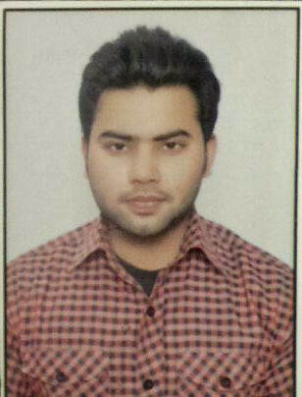
C28A, Sanjay Gram
Rajiv nagar, Sector-14
Gurgaon
Haryana(122001).
 +91-9643131233
E-mail: amitsaini22nov@gmail.com

.
PROFILE & EXPERIENCE

1.8 Years of strong exposure in leading, training and motivating managerial & technical professionals to achieve organizational goals. Core competencies include:
- Networking Technologies
- Virtualization Technologies
- Server Infrastructure
- Private Cloud
- Datacenter Management

NETWORK BULLS PVT. LTD as Microsoft Trainer
Sep 2015 to Till Date

CMS INFOSYSTEM PVT. LTD. as Network Trainer
Feb 2015 to Sep 2015

IIHT NOIDA. as Network Support Engineer & Trainer.
Aug 2014 to Feb 2015.
TECHNICAL & ACADEMIC QUALIFICATIONS

Examination/Degree | Board/University | Performance | Year of Pass-out
Bachelor of Engineering | RIT, ROORKEE(UA) | Aggregate = 68 % | 2014
Diploma in CSE | IETE, DELHI | CGPA = 6.35 | 2010
Secondary Education | C.B.S.E. | Aggregate = 52 % | 2006
TECHNICAL SKILLS

- CCNA (Routing & Switching)
- MCSA (Windows server 2008 & 2012 )
- MCSE (Server Infrastructure, Desktop Infrastructure & Private Cloud)
- VM-WARE (Vsphere 5.5)

Trainings Delivered

4
- CCNA R & S – 10+ Batches
- MCSA (2012)- 10+ Batches
- MCSE (Server Infrastructure)- 3 Batches
- MCSE (Desktop Infrastructure)- 1 Batch
- Vmware VCP (Vsphere 5.5)- 1 Batch
.
HOBBIES & INTEREST

- Reading
- Cooking
- Computer Gaming.
- Listening music
KEY STRENGTH

- Team working capability.
- Never give up attitude.
- Hardworking.
- Easily environment adopting capability
- Positive attitude towards work.
- Good learning capabilities.
PERSONAL PROFILE

NAME : AMIT KUMAR
DATE OF BIRTH : NOVEMBER 22, 1990
SEX : MALE
MARITAL STATUS : SINGLE
NATIONALITY : INDIAN
LANGUAGE PROFICIENCY : HINDI, ENGLISH
FATHER’S NAME : Mr. RAJVEER SINGH SAINI
MOTHER’S NAME : Mrs. MANISHA SAINI
PERMANENT ADDRESS : HNO. 6/5923, STREET NO. 2, VISHNU
DHAM COLONY, NEW MADHO NAGAR, SAHARANPUR, UTTAR PRADESH(247001)

I hereby declare that the above information provided by me is true to the best of my knowledge and belief.

Date……………
Place………….. AMIT KUMAR

